The Effects of an Interactive Game on Learning and Perceived Experience in a Museum Visit

Konstantinos Mikalef
School of Applied Arts
Hellenic Open University
@@address@@, Greece
@mail.gr

Michail N. Giannakos and Konstantinos Chorianopoulos
Department of Informatics
Ionian University
Plateia Tsirigoti 7, Corfu 49100, Greece
{mgiannak, choko}@ionio.gr

Letizia Jaccheri
Department of Computer and Information Science
Norwegian University of Science and Technology
@@address@@, Trondheim 7491, Norway
letizia@idi.ntnu.no

Abstract
Mobile-based applications are increasingly used nowadays to assist learning scenarios at informal setting, such as museums and cultural heritage locations. However, the impact of interactive assistance is yet to be explored. In this paper, we explore the effects of a mobile-based game on learning performance and on perceived museum experience. We developed a mobile game based on QR codes and quiz software for the context of an art museum. In addition to the interactive version of the game, a paper-based version is also employed followed by a between groups evaluation experiment. A total of 55 lyceum (high school) students participated in a controlled experiment that compared the effectiveness of three learning approaches (passive guided tour, paper-based quiz, mobile-based game) and the level of interest in a museum experience among the groups. The results of the evaluation showed that students who played the interactive version of the mixed reality game had higher performance in the post-assessment when compared with the paper based version of the game. In addition, the mobile-based game did not affect students’ interest for visiting the gallery. Further research should consider the effects of higher-fidelity types of mobile-based games, such as 3D graphics, as well as mixed-reality games.
Keywords
Between Group Experiment, Effectiveness Evaluation, Experience Evaluation, Mobile Assisted Learning, Museum.

Introduction

Mobile Technologies enable both immersion into a mixed reality environment (MRE) and more motivating learning experience. Drascic and Milgram (1996) provide the following good working definition for mixed reality environments: “between the extremes of real life and Virtual Reality lies the spectrum of Mixed Reality, in which views of the real world are combined in some proportion with views of a virtual environment” (p. 123). Mixed reality environments are closely related to augment reality than purely physical/digital environments (Schwabe & Göth, 2005). In addition, due to the portability and functionality of mobile devices, they can be used outdoors, in exhibitions and in other non classroom settings, extending the depth and breadth of informal learning.

Researchers have often stressed the benefits of enhancing the functions of museums, parks and exhibitions by designing educational projects connected to learners’ informal learning, (Huang et al., 2010) and making non classroom environments more enjoyable and motivating for learning (Sung et al., 2010). In the context of museums, many of them have employed new technologies and customized mobile devices (Cabrera et al., 2005) for leveraging the interest and the experience of the visitor. For instance, one of the most successful projects was conducted in the Exploratorium of San Francisco (Hsi 2003), this study was one of the pioneers in the direction of combining mobile technology and capturing experience in the real world.

Young generations are exposed to technology to a great extent and as a result they are familiar with various forms of technology and mobile devices in particular. Students spend their time during breaks playing video games, shooting pictures, surfing the web and listening to music, using hi-tech mobile phones and other gadgets. In this research, we have designed a mobile mixed reality game that leverages student familiarity with mobile technology and we devised a controlled experiment in order to explore the educational impact and overall experience using the game.

This study specifically aims to clarify issues regarding the following research questions:
- What is the effect of game interactivity and feedback on student performance during a museum visit?
- What is the effect of game interactivity and feedback on student performance during a post-assessment test, after the museum visit?
- How the introduction of mobile technology affects students’ appreciation of the museum?

The paper is structured as follows. The following section outlines the literature review and the related work. Section 3 describes the design and the implementation of the mixed reality game. Section 4 presents the methodology employed in this study to test (measure) the effectiveness and the experience of the three different learning scenarios. Section 5 presents the empirical results while the sixth section of this paper discusses the results. Finally, the paper concludes with theoretical and practical implications and recommendations for future research.

Related Research/Literature Review

The importance of “traditional” video games in education, which has been argued already for over a decade (Gee, 2004; Prensky, 2002; Van Eck, 2006), seems lately to win ground in formal education. Derek Robertson National Adviser for Emerging Technologies and Learning at Scotland stated recently that “Educational needs of young people in the UK are changing. Children don’t come to school from a vacuum; they come to school from a cultural framework that schools need to embrace and accept.” Nowadays game assisted learning has received increased attention from scholars and educators. In the field of game assisted learning many successful examples have been reported (Papastergiou, 2009; Virvou and Katsionis, 2008). Games provide structure for interactions and reward and promote students in many learning contexts. As such, games leverage students’ experience with the learning context and increase the educational effectiveness (Virvou et al., 2005; Papastergiou, 2009).

Numerous researchers continue to examine the performance and experience benefits from the impact of digital games and environments on learning (Teng et al., 2012; Papastergiou, 2009; Tan, 2007). Past research has shown that games generate a positive effect and experience for players (Virvou et al., 2005), in which it can lead to increased learning (Skadberg & Kimmel, 2004; Schwabe & Goth, 2005) and increased exploratory behavior (Kiili, 2005). Moreover, games encourage students to participate through an interactive environment. In addition, researchers discovered that educational games can increase students’ motivation to learn (Huang, 2010). Summarizing, game assisted learning provides several advantages to support learning. For instance, games promoting learning, making learning fun, and increasing students’ satisfaction, enjoyment and motivation, which further influence their intention.

However the dispute, on the characteristics an educational game should encompass, is ongoing, Prensky (2002) states that educational games lack fun and motivation. To overcome this, he emphasizes the role of gameplay, i.e. the activities and strategies designers should employ “to get and keep the player engaged and motivated to complete each level and an entire game” and he suggest that continuous appropriate challenge and uncertainty should be present. De Castell and Jenson (2003) suggest that gameplay elements connected with content and context elements as well as freedom of movement in space, makes a game immersive. While Paras and Bizzocchi (2005) argue that these are only exogenous tendencies whereas learners ought to enter the “magic circle”. To succeed this in a digital environment the spatial and encyclopedic properties are the most important. The former refers to graphics and sounds that entice players and the latter refers to the right encyclopedic level, which should be in harmony with student’s input.

Research in educational games argues that well-designed game can meet some of the needs of children and motivate them to learn (Garzotto, 2007; Tarumi et al., 2008). Playing learning games encourages interactions and stimulates collaboration (Schrier, 2006). Collaborative playing requires different skills to be deployed simultaneously (Kolpfer et al, 2005). Evidence of learning performance of educational games has been shown, successful teach in several areas, such as history (Ardito and Lanzilotti, 2008), arts (Klopfer et al., 2005) and cultural heritage (Francesca-Costabile et al., 2010)

Portable devices have been successfully employed as learning tools in both formal and informal learning contexts. In the formal learning, handhelds have been used in teaching both within the classroom setting (DiGiano et al. 2003) and out-classroom (Chen et al. 2003). In addition, the potential of handhelds to assist informal learning has been explored through different frameworks. For instance, handhelds have been used as museum guidebooks (Hsi 2003; Sung et al., 2010) or as learning systems (Huang et al., 2010).

Many studies have shown the potential of portable devices to increase learning opportunities. Informal learning and mixed learning with the real world experiences are some of the most remarkable advantages. Mobile devices’ portability and functionality make them suitable for out-classroom learning, for instance birdwatching (Chen et al., 2003), plant hunting (Huang et al., 2010) and museum guiding (Hsi, 2003) are some of the most successful case studies. As such, it is subsequent that the use of mobile devices would bring many benefits and opportunities for informal learning in future.

Game Development and Implementation

We have designed a simple quiz game that is based on questions, total score and a limited time to complete. Although the game is not advanced with respect to graphics, narrative, and interactivity, it includes other main game elements, such as purpose, rules, score, and limitations (space-time). The main purpose of the game was to identify a series of paintings, at an Art Museum, based on a visual elements description. The game was played by teams of two players, who are given 25 minutes to answer 12 questions that lead them to certain paintings. The team with the highest number of correct answers wins. In case of draw, the team which completed the game first wins.

We used two free (one of them open-source) computer tools for implementing the game, a QR application and a quiz application. The only hardware requirement for running the software was a java enabled mobile phone. Camera feature was a requirement for the QR application (http://qrcode.sourceforge.jp). The design of the questions was implemented with MyMLE (http://mle.sourceforge.net) application (Figure 1), which allows creating mobile learning content. There was no coding required in developing the quiz of questions.

In order to investigate the game-play aspects of the game two pilot teams were employed. The teams were briefed first and were given a demo quiz to familiarize themselves with the software, before playing. No time constrains were established at this time for the game, nevertheless teams were encouraged to complete the game without hassle. Upon completion the 25 minutes of playing time was considered adequate. Besides, pilot teams suggested readjusting some QR codes to a height of approximately 130 cm (Figure 1), to allow easier focusing the camera for scanning the code, which we did.

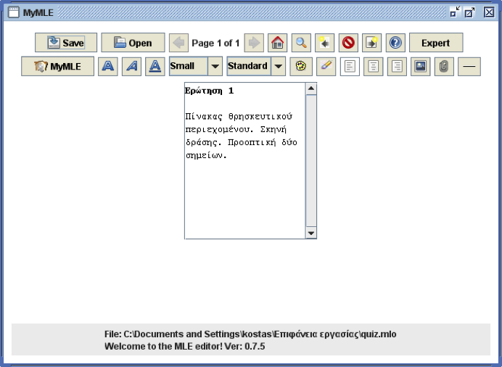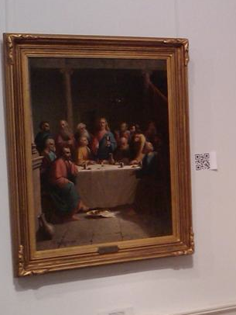
Figure 1. MyMLE software was employed to create an interactive questionnaire for mobile phones (left). The QR codes were placed next to the paintings (right)

There are two versions of the game, a Mixed Reality (MR) and a paper-based (PB) version. In MR version QR codes are placed next to paintings. Each team was provided two mobile phones, one where questions were displayed and answers were typed in, and a second one which was used to scan QR codes. When the players identify a painting as an answer to a question they scan the QR code next to it and type a four digit number as the answer (Figure 2). If the answer was correct they get a message indicating so, while in the opposite case they got a message indicating that they have one more chance to answer correctly. Hence in total each team was given up to two chances to identify a correct answer.

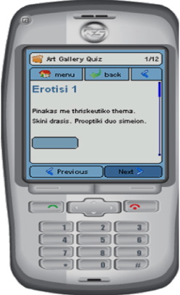
Figure 2. The mobile game (left), QR code (right)

The PB version of the game was identical, except from the fact QR codes were replaced with blank post-its and the questions were printed on paper. However the major difference in the gameplay between the two versions was that players do not receive any feedback regarding their answers, during the PB game.

Twenty four out of approximately eighty paintings from the Gallery’s permanent collection, from all areas of the Gallery, were employed as potential answers to one of the game’s questions. Only next to these paintings a QR code (or post-it at the PB version) was placed. The total number of paintings (double than the total number of questions) was chosen in order to make the game moderately difficult and to avoid possible ambiguities. The selection of the paintings as well as question writing and order of appearance was accomplished in collaboration with gallery’s registrar.

Methodology

Subjects

The initial sample of the study was sixty 1st grade lyceum (upper general secondary school) students, aged between 15 and 16 years. All the students were attending an elective course in ICT and multimedia at a general lyceum at Corfu, Greece. At the study we employed three groups of twenty students each, which corresponded to the three different classes of the aforementioned course. Group A consisted of 16 males and 4 females, Group B consisted of 17 males and 3 females and Group C consisted of 16 males, 4 females. It should be noted that according to the school’s policy students were assigned to the classes of the elective course in a rather “random” manner. At the initial sample of 60 students, we had 5 drop-outs, one female student from Group A, two female students from Group B and two male students from Group C, leaving a total of 55 (19 for the first group, and 18 for the remaining two).

Measures

Three types of measures were employed in this survey: data from the game, data from the final assessment and data from a questionnaire.

Playing time, number of correct answers, number of second answers was collected from the game. For the final test (effectiveness) a 12 item assessment, consisting of multiple choice questions, was employed (formal test - assessment). Students were presented with a series of pictures and had to choose one out of the four descriptions that was more accurate. The description was referring to the same visual elements that were also employed during the game, which were combinations of all of the following: primary and secondary colors, warm and cold colors, geometric and organic shapes, depth and perspective.

A 13 item questionnaire was developed to assess students’ attitude towards ICT and their interest in the museum (and game) experience. In order to explore the situational interest, we relied on self-report with 5 point Likert-scale, which is the most common approach. Due to the lack of relative research in the field of arts the questions used followed the “pattern” of other educational fields like mathematics and physics. (Harackiewicz et al., 2008; Hulleman et al., 2008). For all responses we employed a balanced interval scale with values from 1 to 5 (1 for strongly agree and 5 for strongly disagree).

Experiment Design

A quasi-experimental design, with three non-equivalent groups, with two posttests was used in this study. In notational form, the design can be depicted as:

N | X₁ | O_{1,2}
N | X₂ | O_{1,2}
N |  | O_{1,2}
Figure 1.The Experiment Design

Each line corresponds to one of the groups A, B and C respectively. N stands for an non-equivalent group, O_{1,2} are the two measures (questionnaire and final test), and X₁ and X₂ two are the treatments i.e. the Mixed Reality game and the paper-based game respectively. The drop out was 5% (N=1) for the first group (MR) and 10% (N=2) for each of the remaining two groups. This is due to the fact that some students did not attend some part of the study, however the rates are quite low leaving and the groups can be considered approximately equal.

The type of design we employed is not considered in general as strong as a randomized experiment (Cook et al., 2002.). However according to Marczyk et al., (2005) a non-equivalent groups posttest-only design has potential application in representing a different type of teaching method, which is actually our case, since the game was integrated at the educational process. Besides, in order to strengthen the design we also introduced a control group. It should be noted that no significant difference was found between the three groups in terms of age, gender and school grades, according to the analysis that took place at the beginning of our study.

Procedures

The study was conducted over a three week period from 10th to 28th of May 2010. During the first week formal classroom teaching was held. At the second week students visited the Art Gallery (Figure 4) of the Municipality of Corfu and at the third week the posttest (questionnaire and final test) took place.

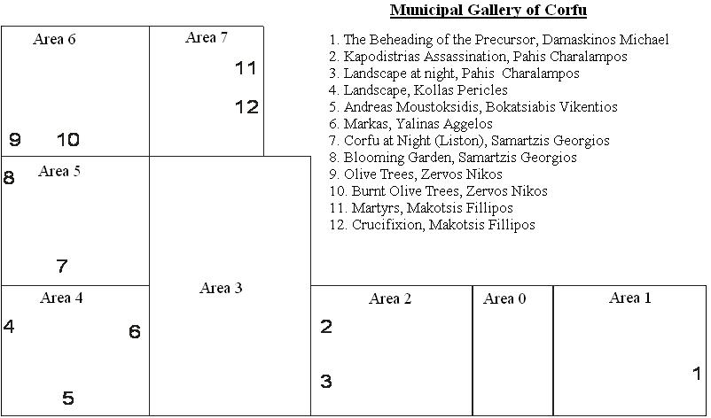
Figure 4. The layout of the public art gallery

During the first week of the study, students were taught in the classroom the basic principles of visual elements in works of art. The teaching lasted two school hours, during which students were presented with example of paintings and had the chance to use the Artist’s Toolkit (Artconnected, http://www.artsconnected.org/toolkit/index.html), which is design for visual elements teaching.

The following week each of the groups visited the gallery at a different time, and attended a guided tour. The duration of the tour was approximately 45minutes. Upon completion of the tour students from Group A and Group B were briefed on the rules and played the game (mobile- and paper-based respectively) (figure 5). The students of Group A, were also provided with mobile phones with a sample quiz as well as sample QR codes in order to familiarize themselves with the software. The same devices were used during the game. Students of Group C where given instead 30 minutes extra time to spend at the gallery (extended tour), in order to identify visual elements on their own as they wished. For the final week of the study, the students from all three groups took the formal test (assessment) and answered the questionnaire.

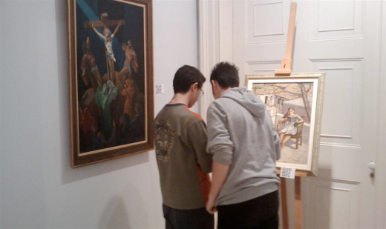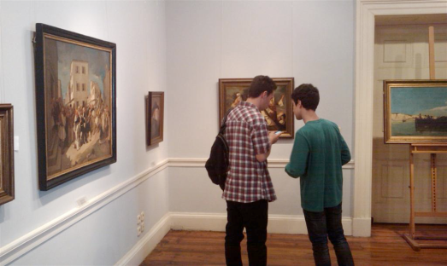
Figure 5. Students of the mixed reality game were immersed in questions displayed on their mobile phones

Data Analysis

Firstly, in order to examine the difference in correct answers in MB and PB games, we conducted a Mann-Whitney U test. Additionally, in order to examine the improvement of interactivity when the second (i.e. final) answers for Group A were taken into account a Mann-Whitney U test was conducted among Group A and Group B final correct answers.
Except for the data provided by the correct answers of the game, this study gathered information from cognitive tests and surveys at the end of the procedures of three groups. As such in order to examine the differences among mixed reality, paper based game and extended tour guide on students’ effectiveness and interest in the museum context, a post hoc test was conducted. A Games Howell criterion was used in order to examine separately for each group the influence of 1) mobile-based game, 2) paper-based game and 3) extended tour guide on students’ effectiveness and interest.

Results

Game Findings and Interactivity

Students from both Groups A and B spent approximately 19 min on average, at the gallery during the game session. Students from Group C, given the extra time of 30 minutes, used approximately 20 minutes in the gallery. We can therefore quite safely assume that all three groups spent roughly the same total time at the gallery.

To address the difference on correct answers among MB and BP games, a Mann–Whitney U test was conducted. Using a Mann-Whitney U test of two groups, Group A (M₁=8.84, SD₁=1.80) and Group B (M₂=9.22, SD₂=2.07), the results showed a statistically insignificant difference U= 145.00, z= -0.805, p= .421. Students from Group A had an average rank of 17.63, while students from Group B had an average rank of 20.44. As a consequence, there is no significant difference between MB and PB game correct answers.

Due to the interactivity (feedback) of the MR version of the game students from Group A had the chance to correct an incorrect answer. However, when the final answers of Group A are taken into account (M = 10.95, SD = 1.22) the results are completely opposite. Therefore, a Mann-Whitney U test was conducted, only this time the second (i.e. final) answers for Group A were taken into account. The test indicated that there is a highly statistical difference between the answers of the two Groups, U= 84.0 , z= -2.71, p= .007. Students from Group A had an average rank of 23.58, while students from Group B had an average rank of 14.17.

It is also of interest to mention that while there is no student from Group A who answered correctly all 12 questions initially, 47% of them (N = 9) did finally, using the second chance opportunity. In contrast only 11% (N = 2) of students from Group got all 12 answers correct. Thus we can conclude that the interactivity of the MR version of the game had a substantial positive impact on students of finding the right answers during the game, when compared with the PB version

Effectiveness

To examine the hypotheses regarding students’ effectiveness, the Post-hoc analyses were conducted. Games – Howell criterion was used to verify whether the different learning procedures (Group) are related to the different effectiveness of the students. The results summarised in Table 1, highlighted a signiﬁcant diﬀerence between the effectiveness of Group A and Group B. In addition, post-hoc tests also revealed an insigniﬁcant relationship between Group B and Group C and Group C and Group A.

Table 1. Testing the differences in effectiveness among the three groups
 | -Mean- (SD) |  | Mean Difference (I-J) | Std. Error | Sign
Effectiveness | (I) | (J)
Effectiveness | Group A -9.00- (2.08) | Group B -7.28- (1.67) | 1.72 | 0.62 | 0.02*
Effectiveness | Group B -7.28- (1.67) | Group C -8.50- (1.79) | -1.22 | 0.58 | 0.10
Effectiveness | Group C -8.50- (1.79) | Group A -9.00- (2.08) | -0.50 | 0.64 | 0.72
*p<0.01 ; SD, Standard Deviation

Based on the frequency analysis between Group B and C, it can be inferred that even though both methods produced almost the same performance in the experiment, Group C produced a greater academic performance than Group B, whereas most of the students in Group C scored with up to 9 correct answers (Figure 6).

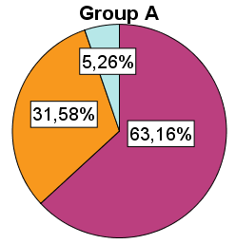 | 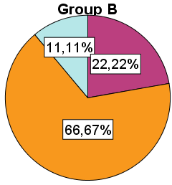  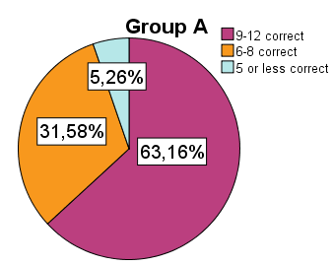 | 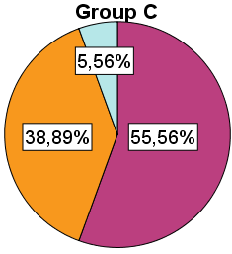
Figure 6. Frequency Diagrams

Interest with the Experience

To examine the hypotheses regarding students’ interest for the museum experience, the Post-hoc analyses were conducted. Games – Howell criterion was used to verify whether the diﬀerent learning procedures (Group) are related to students’ interest for museum experience. The results summarised in Table 2, highlighted an insigniﬁcant diﬀerence among all the Groups. This indicates that playing games (using mixed reality or not) does not influence students interest for the museum experience.

Table 1. Testing the differences in Interest among the three groups
 | -Mean- (SD) |  | Mean Deference (I-J) | Std. Error | Sign
Interest | (I) | (J)
Interest | Group A -3.16- (0.83) | Group B -3.33- (0.91) | -0.18 | 0.28 | 0.80
Interest | Group B -3.33- (0.91) | Group C -3.61- (0.78) | -0.28 | 0.28 | 0.59
Interest | Group C -3.61- (0.78) | Group A -3.16- (0.83) | 0.45 | 0.28 | 0.24

Discussion

The results of our research allow us to argue that the enhancement of mobile device in a learning game context benefits students’ performance in a highly significant way. This result may be explained from previous findings in the literature (e.g., Huang et al., 2010; Sandberg et al., 2011) stating that the usage of mobile devices motivates students and offers sufficient learning opportunities to improve learning procedures. From research we do not have sufficient evidence to suggest that the usage of a mixed reality game affects students’ interest regarding the non classroom learning environment. Hence, we can argue that with the interactivity of mixed reality can improve the effectiveness of game based learning and can compete the extended guiding effectiveness in a non classroom environment without loss of interest for the environment.

According to the results of students’ final performance, in Group A no student scored less than five correct answers at the final test, while one student from each of the remaining two groups did. In addition to that 21.0% (N = 4) of the students in Group A got all 12 questions right at the final test, while none of the students from the other groups did. Moreover from the statistical analysis a significant benefit on students’ performance is indicated, from the usage of the MR version of the game over the PB version. However there is not enough evidence that this benefit is significantly higher in the case where the comparison is made with the extended tour. The above findings may be explained by the fact that interactive mobile-based games are able to attract and engage students better than paper based games.

According to Oblinger (2004) games have many attributes associated with learning. The attributes we embraced in our game include: Activation of prior learning, Feedback and assessment, Social, Experiential. The last three of them apply in a higher degree at the MR version of the game due to feedback which was provided during the game. Therefore not only students were able to assess their progress at the game, but they also had to discuss actively in order to find the right answers. The opportunity to experiment was also an asset provided to them through the option of having a second chance in answering, since “Learning is often by trial and error: hypotheses are tested and users learn from the results.”

The evidence from past research with regard to performance or knowledge acquisitions is not clear. It is worth mentioning at this point that relatively few studies investigate the effects of a game (Mixed Reality or not) against a formal test. An early study showed that a simulation game had positive effect to students attending a marketing course, improving their quantitative skills, but it was not effective in terms of acquisition of applied or theoretical knowledge (Whiteley & Faria, 1989).

The researchers of Savannah game (Facer et al., 2004) claim that mobile gaming could support learning, but they are not conclusive in “how to do so effectively”. They underline as the least successful aspect of the attempt to combine a ‘formal “schooled” experience’ to the game and also technical difficulties causing a negative influence to the interaction within it. Technical difficulties and restrictions arose also in an archeological site exploration game, where a paper based and a Mixed Reality based version were employed, with the latter restricting students to follow a sequential order in tackling the tasks (Costabile et al., 2008). As a result the performance of the students played the Mixed Reality version was lower, which is contrast with our findings.

According to De Castell and Jenson (2003) educational computer games suffer from disincentivites and especially “an insistence on developmental assessment developmental assessment whereby players cannot ‘move on’ in the game until they complete, in linear and lock-step fashion, particular tasks and/or skills; no potential within a game for chance/luck and no room for intuitive leaps or ‘twitch-speed’ perception and skill” and “few opportunities for instant feedback”. These disincentivites are tackled effectively at the MR version of the game.

The evidence we found showed both increased interest (Ruchter, Klar, & Geiger, 2010) and significant better performance at the formal exam (Chen, Kao, & Sheu, 2003; Lai et al, 2007) is in accordance with other studies.

To sum up, the following figure (figure 7) can provide us a useful summary regarding the study.

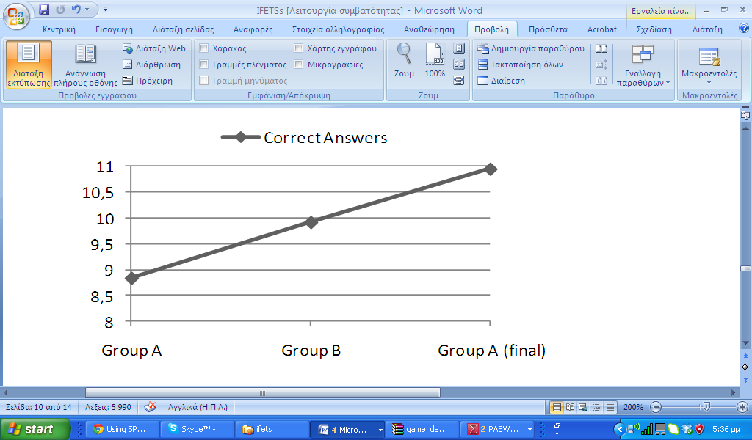 | 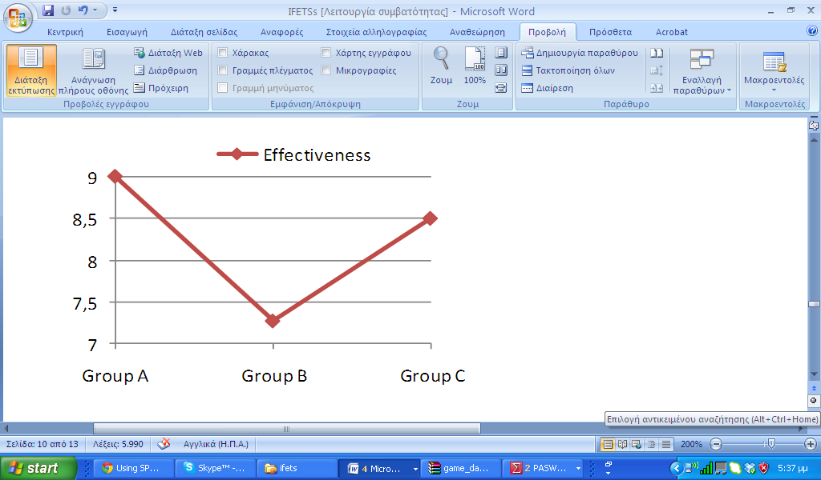 | 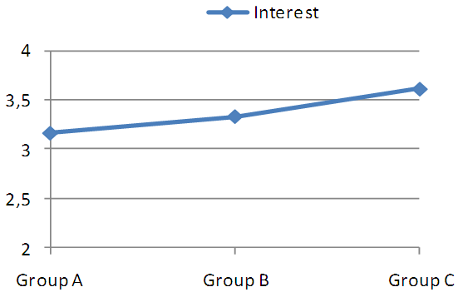
Figure 7. Diagram regarding correct answers (left), effectiveness (middle) and interest (right) among the groups

Conclusions

The current study is one of the few so far, where a mobile mixed reality game assists an educational process. Conducting a field study, of this kind with a sample of a 55 students, was not an easy task, especially when social interaction threats are concerned. The overall results prove that the mobile mixed reality game had a positive effect, on students’ performance at the final test and also does not affect their interest for visiting the gallery.

Especially, an interesting finding of this study is that a Mixed Reality based game can produce a good performance (similar to the tour guide) in the museum environment. Moreover, using Mixed Reality in a game based context, the performance of students increased. As such, the enhancement of Mixed Reality technology in game context can benefit students’ performance. Therefore it could be accepted that a Mixed Reality based game will be a very useful tool that can help in several outdoor environments (museum), and it certainly could be a beneficial medium capable of assisting learning.

The study also showed that interactivity of the MR version of the game had a substantial positive impact on students of finding the right answers during the game, when compared with the PB version. With regard to students’ performance (effectiveness), there is evidence that students who played the MR version of the game benefited significantly more than those who played the PB version. However, we did not find evidence that this benefit is significantly higher when compared with the extended tour.

Summarizing the study was successful, mainly for the following reasons:
- The game relied on gameplay. A set of rules that increased competition was employed.
- Mixed Reality device did not speed down or pose any limitation to the game. On the contrary they provided instant feedback during the game enhanced the gameplay.
- The introduction of Mixed Reality did not take the interest out of the relative curriculum, Students still focus on the painting to identify the visual elements.
- The game was integral part of the educational process – not a standalone event.

The findings of this study must be interpreted in light of some potential limitations. First, the generalizability of this study must be carefully made, as it was conducted in a single context with specific instructions. Secondly, the design was limited to students at one grade level and was not longitudinal, therefore the data could not reveal the continuation of the Mixed Reality based behavior. Despite these limitations, the findings generate valuable insights, which can be used as part of hypotheses for representative follow-up studies in technological tools’ educational effectiveness and experience.

Further studies may consider aiming to reveal several insights. First investigating the effect of the game in low ability, in the specific subject, students compared with high ability students. Second investigating the effect of the game in students’ performance under different context and long term period. Also, another study involving different educational levels and students with different levels of computer experience might draw several important conclusions. Further research also needs to examine students’ intention to adopt Mixed Reality based learning.

References

Ardito C, Lanzilotti, R. “Isn't this archaeological site exciting!”: a mobile system enhancing school trips, Proceedings of the working conference on Advanced visual interfaces, 2008.

Cabrera J.S., Frutos H.M., Stoica A.G., Avouris N., Dimitriadis Y., Fiotakis G. & Liveri K.D. (2005) Mystery in the museum: collaborative learning activities using handheld devices. Paper presented at the 7th International Conference on Human Computer Interaction with Mobile Devices & Services.

Chen, Y., Kao, T., and Sheu, J. A mobile learning system for scaffolding bird watching learning. J. Computer-Assisted Learning 19 (2003), 347–359.

Cook, T.D. Shadish W., and Campbell D., Experimental and Quasi-Experimental Designs for Generalized Causal Inference. Houghton Mifflin, 2002.

Costabile, M.F., De Angeli, A., Lanzilotti, R., Ardito, C., Buono, P., Pederson, T. Explore! Possibilities and Challenges of Mobile Learning. In Proceedings of CHI 2008. ACM Press, New York, NY.

De Castell, S., & Jenson, J. (2003). OP-ED: Serious play. Journal of Curriculum Studies, 35(6).

DiGiano C., Yarnall L., Patton C., Roschelle J., Tatar D. & Manley M. (2003) Conceptual tools for planning for the wireless classroom. Journal of Computer Assisted Learning 19, 284–297

Drascic, D., and Milgram, P. (1996) Perceptual Issues in Augmented Reality. In Bolas, M.T., Fisher S.S. and Merritt, J.O. (Eds.) SPIE Volume 2653: Stereoscopic Displays and Virtual Reality Systems III. San Jose, California, USA, 123-134.

Facer, K., Joiner, R., Stanton, D., Reid, J., Hull, R. and Kirk, D. (2004), Savannah: mobile gaming and learning?. Journal of Computer Assisted Learning, 20, 399–409. doi: 10.1111/j.1365-2729.2004.00105.x

Francesca-Costabile M, Ardito C, Lanzilotti,R. (2010). Enjoying cultural heritage thanks to mobile technology, interactions, 17(3).

Garzotto, F. Investigating the educational Effective-ness of multiplayer online games for children. Proc. IDC 2007, ACM Press (2007)

Gee, J. P. (2004). What Video Games Have to Teach Us About Learning and Literacy. New York: Palgrave Macmillan.

Harackiewicz J.M., Durik, A.M. Barron, K.E. Linnenbrink-Garcia L. and Tauer, J.M. (2008). The role of achievement goals in the development of interest: Reciprocal relations between achievement goals, interest, and performance. Journal of Educational Psychology, 100 1, 105–122.

Hsi H. (2003) A study of user experiences mediated by nomadic web content in a museum. Journal of Computer Assisted Learning 19, 308–319. doi: 10.1046/j.0266-4909.2003.jca_023.x

Huang Y., Lin Y. & Cheng S. (2010) Effectiveness of a mobile plant learning system in a science curriculum in Taiwanese elementary education. Computers & Education 54, 47–58. doi:10.1016/j.compedu.2009.07.006

Huang, W. H. (2010). Evaluating learners' motivational and cognitive processing in an online game-based learning environment. Computers in Human Behavior. doi: 10.1016/j.chb.2010.07.021

Hulleman, C.S. Durik, A.M. Schweigert S.B. and Harackiewicz, J.M. (2008). Task values, achievement goals, and interest: An integrative analysis. Journal of Educational Psychology, 100 2, 398–416.

Kiili, K. (2005). Digital game-based learning: Towards an experiential gaming model. Internet and Higher Education, 8, 13–24.

Klopfer, E., et al. Mystery at the museum: a colla-borative game for museum education. Proc. CSCL 2005, ACM Press (2005), 316-320

Lai, C.-H., Yang, J.-C., Chen, F.-C., Ho, C.-W. and Chan, T.-W. (2007), Affordances of mobile technologies for experiential learning: the interplay of technology and pedagogical practices. Journal of Computer Assisted Learning, 23, 326–337. doi: 10.1111/j.1365-2729.2007.00237.x

Marczyk, G., DeMatteo, D., & Festinger, D. (2005). Essentials of Research Design and Methodology, NJ: John Wiley.

Oblinger, D. (2004). The Next Generation of Educational Engagement. Journal of Interactive Media in Education, 2004 (8). Special Issue on the Educational Semantic Web. ISSN:1365-893X

Papastergiou, M. (2009). Digital game-based learning in high school computer science education: impact on educational effectiveness and student motivation. Computers & Education, 52(1), 1-12

Paras B. and Bizzocchi, J Game, Motivation, and Effective Learning: An Integrated Model for Educational Game Design, in Digra, 2005.

Prensky, M. (2002). The Motivation of Gameplay: or, the REAL 21st century learning revolution. On The Horizon, 10(1).

Rogers Y, Scaife M, Gabrielli S, Smith H, Harris E (2002) A conceptual framework for mixed reality environments: Designing novel learning activities for young children. Presence, 11(6), 677–68

Ruchter, M, Klar, B and Geiger. (2010). Comparing the effects of mobile computers and traditional approaches in environmental education. Comput. Educ, 54(4), 1054-1067. DOI= http://dx.doi.org/10.1016/j.compedu.2009.10.010

Sandberg, J., Maris, M., & de Geus, K. (2011). Mobile English learning: An evidence-based study with fifth graders. Computers & Education 57, 1334-1347. doi:10.1016/j.compedu.2011.01.015

Schrier, K. Using augmented reality games to teach 21st century skills. In Proc. SIGGRAPH 2006.

Schwabe G. & Göth C. (2005) Mobile learning with a mobile game: design and motivational effects. Journal of Computer Assisted Learning 21, 204–216.

Skadberg, Y. X., & Kimmel, J. R. (2004). Visitors’ flow experience while browsing a web site: Its measurement, contributing factors, and consequences. Computers in Human Behavior, 20, 403–422.

Sung Y.T., Chang K.E., Hou H.T. & Chen P.F. (2010) Designing an electronic guidebook for learning engagement in a museum of history. Computers in Human Behavior 26, 74–83.

Tan, K. H. (2007). Comparing games and case methods in enhancing student learning. International Journal of Innovation and Learning, 4(3), 224–236.

Tarumi, H., Yamada, K., Daikoku, T., Kusunoki, F., Inagaki, S., Takenaka, M., Hayashi, T., and Yano, M. KEI-time traveler: visiting a past world with mobile phones to enhance learning motivation. In Proceedings of the 7th international Conference on interaction Design and Children. IDC '08. ACM, New York, 161-164.

Teng, D. C, Chen N-S, Kinshuk, Leo T, (2012). Exploring students' learning experience in an international online research seminar in the Synchronous Cyber Classroom. Computers & Education, 58(3), 918-930.

Van Eck, R. (2006). Digital Game-Based Learning: It's Not Just the Digital Natives Who Are Restless…. EDUCAUSE Review , 41 (2).

Virvou, M., and Katsionis, G. (2008). On the usability and likeability of virtual reality games for education: The case of VR-ENGAGE, Computers and Education, 50, 154–178.

Virvou, M., Katsionis, G., and Manos, K. (2005). Combining software games with education: evaluation of its educational effectiveness. Educational Technology & Society, 8(2), 54-65.

Whiteley, T. R.Faria, A. J. (1989). A study of the relationship between student final exam performance and simulation game participation, Simulation and Gaming, 20(1), 44-64.

